1.20 Pre and Post Processors



This section will guide you to understand:

* How to add pre and post processors in JMeter

**Development Environment:**

* Apache JMeter 5.1.1 Version
* JDK Runtime Environment 8.1

This guide has three subsections, namely:

1.20.1 Adding preprocessor

1.20.2 Adding postprocessor

1.20.3 Pushing the code to GitHub repositories

**Step 1.20.1:** Adding preprocessor

* Right click on Test Plan-->Add-->Threads-->Thread Group.

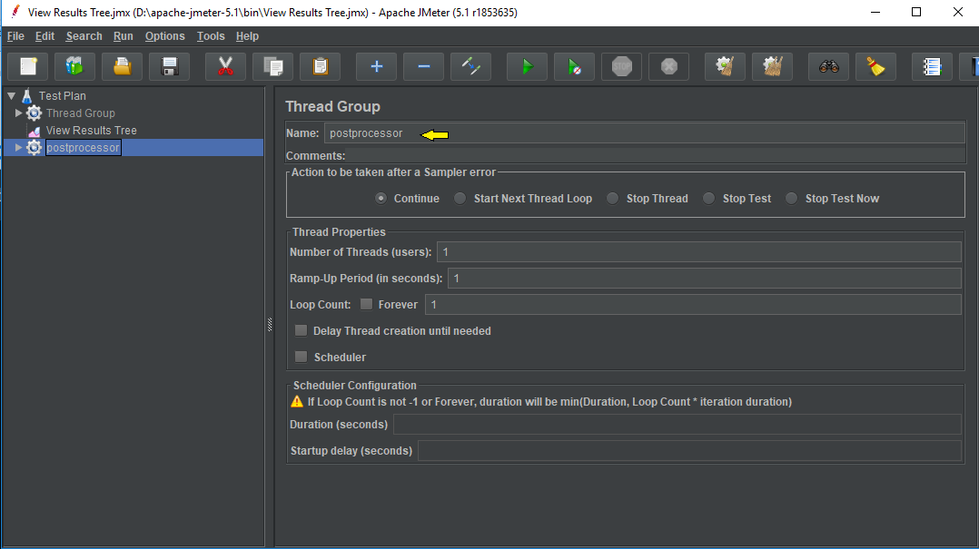

* Right click on Thread-->Add-->PreProcessor -->User parameters.

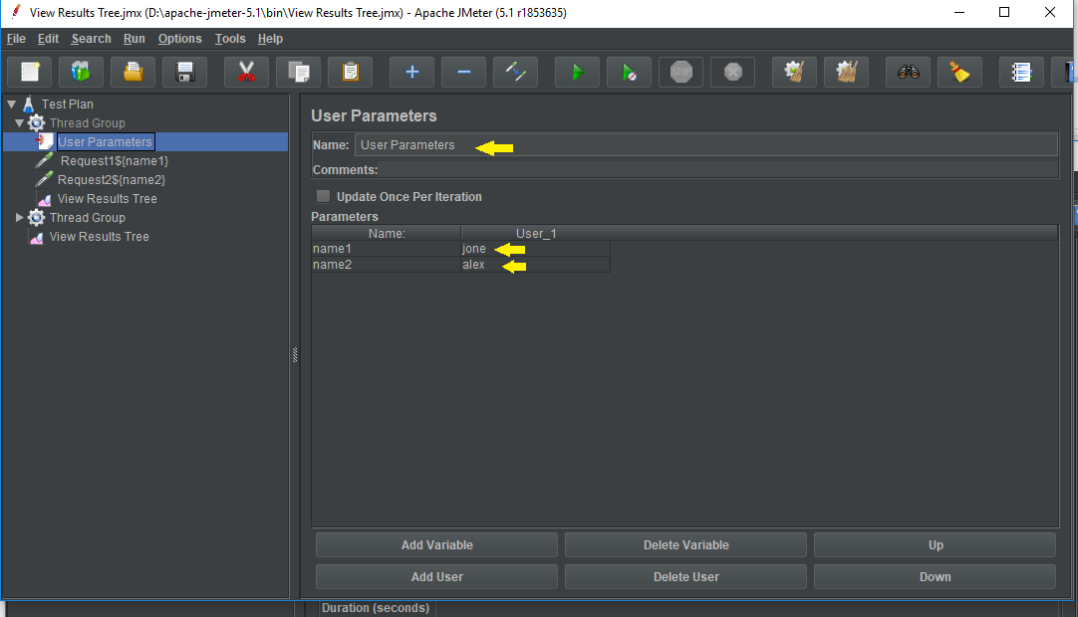

* Right click on Thread Group-->Add two Sampler-->HTTP Request.

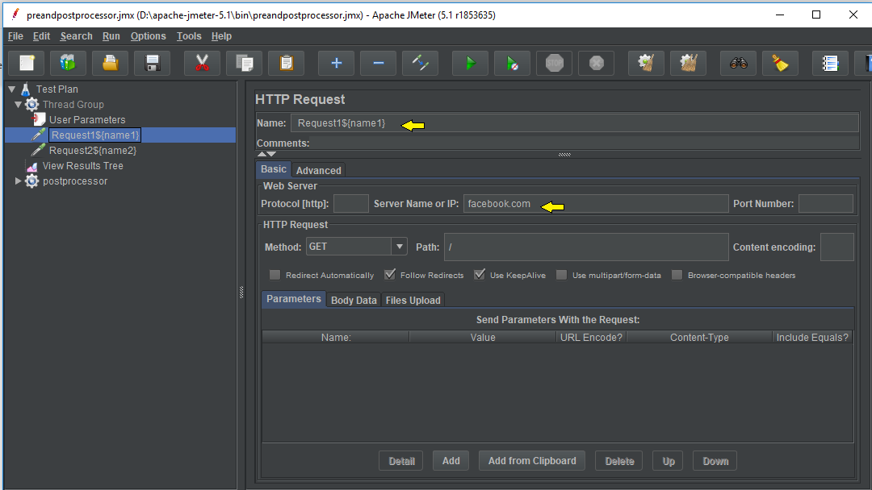

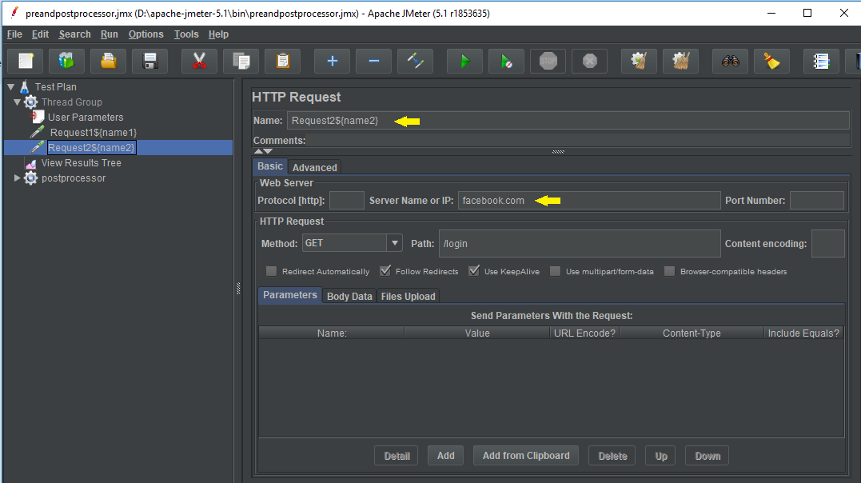

**Steps 1.20.2:** Adding postprocessor

* Right click on Test Plan-->Add-->Threads-->Thread Group.



* Right click on Thread Group-->Add -->Sampler-->HTTP Request1.

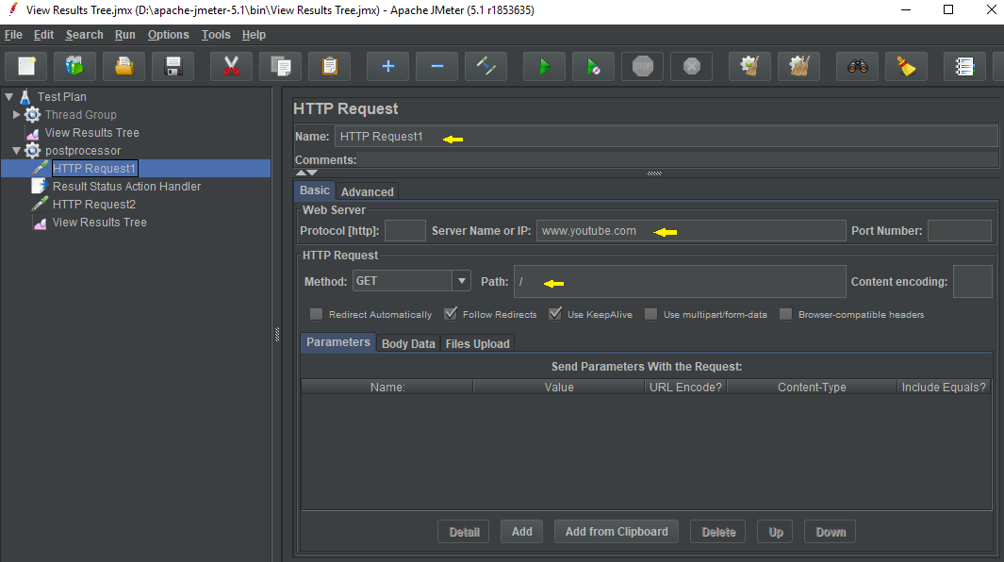

* Right click on PostProcessor Thread Group-->Add-->PostProcessor -->Result Status Action Handler.

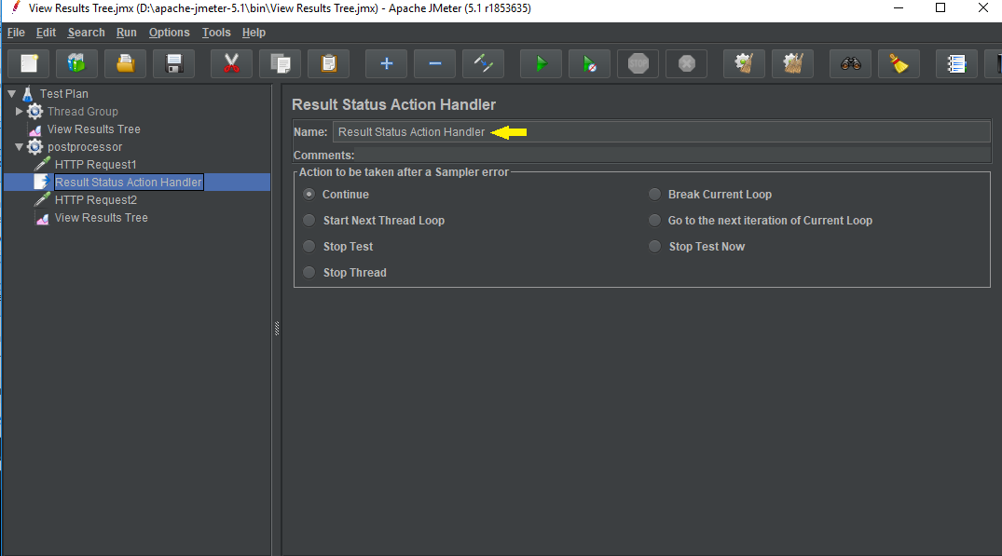

* Right click on Thread Group-->Add -->Sampler-->Add another HTTP Request2 under Result Status Action Handler.

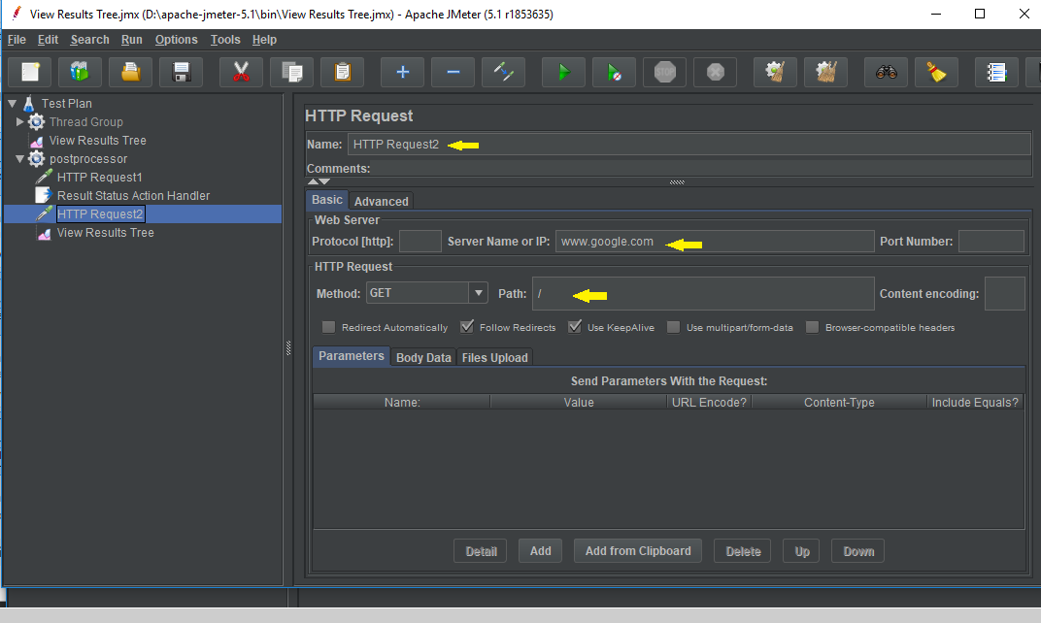

* Right click on PostProcessor -->Add --> Listener-->Run.

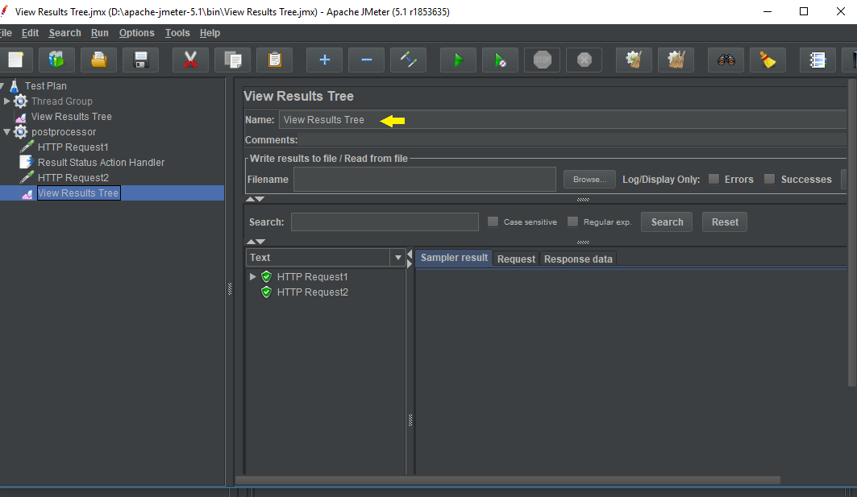

**Step 1.20.3:** Pushing the code to GitHub repositories

Open your command prompt and navigate to the folder where you have created your files.

cd <folder path>

Initialize your repository using the following command:

git init

Add all the files to your git repository using the following command:

git add . 

Commit the changes using the following command:

git commit . -m “Changes have been committed.”

Push the files to the folder you initially created using the following command:

git push -u origin master